<https://www.kaggle.com/lava18/google-play-store-apps?select=googleplaystore.csv>

Showing the trend of the categories and reviews of apps in googleplay store app.

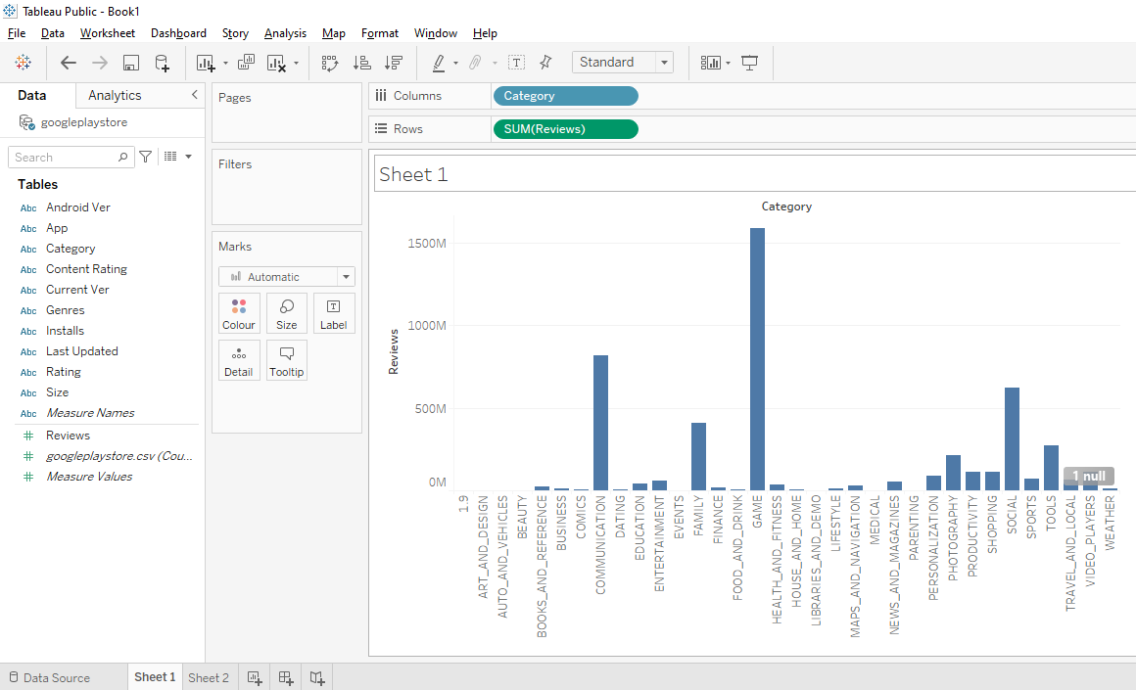

<https://www.kaggle.com/lava18/google-play-store-apps?select=googleplaystore.csv>

Result showing the genres and its reviews based on the category.

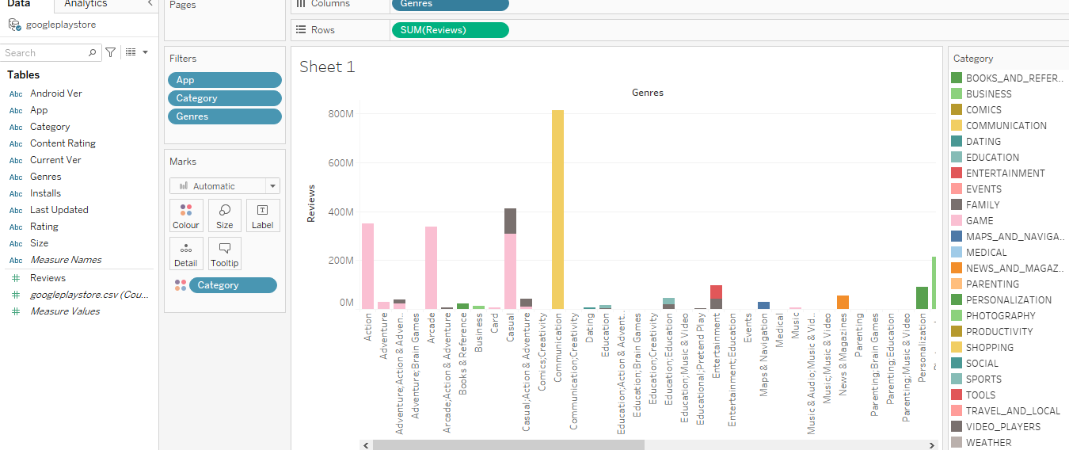

<https://www.kaggle.com/jr2ngb/superstore-data>

Showing the discount that was given per year and quarter wise.

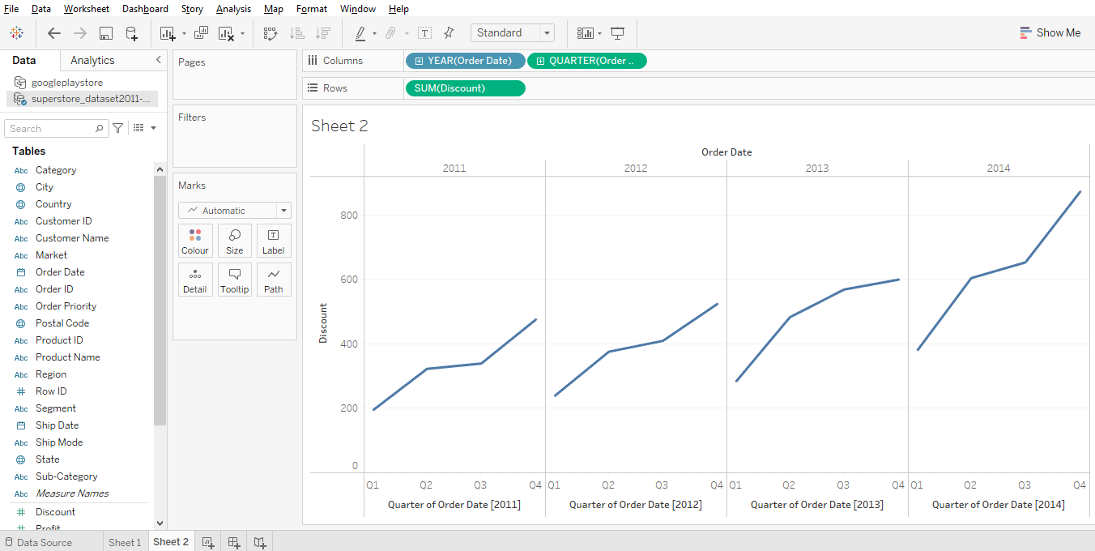

<https://www.kaggle.com/gpreda/covid-world-vaccination-progress>

Report showing total vaccinations given to different countries and what vaccines distributed among different countries.

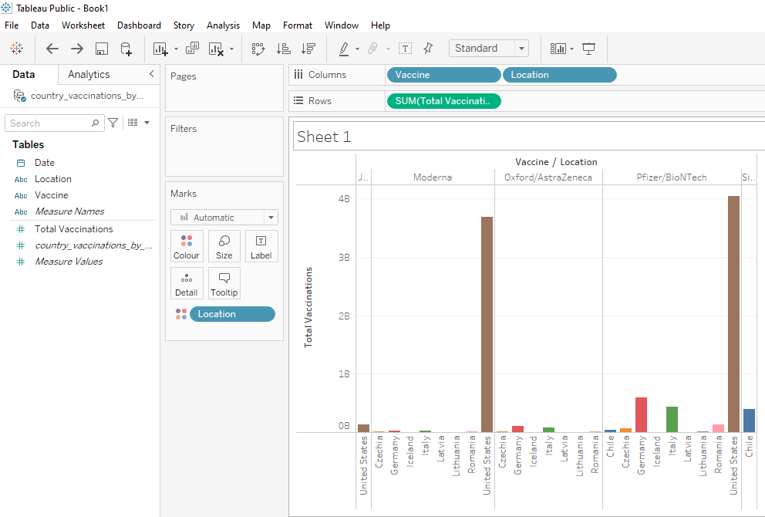

<https://www.kaggle.com/gpreda/covid-world-vaccination-progress>

Result showing the vaccine given location wise in quarterly process.

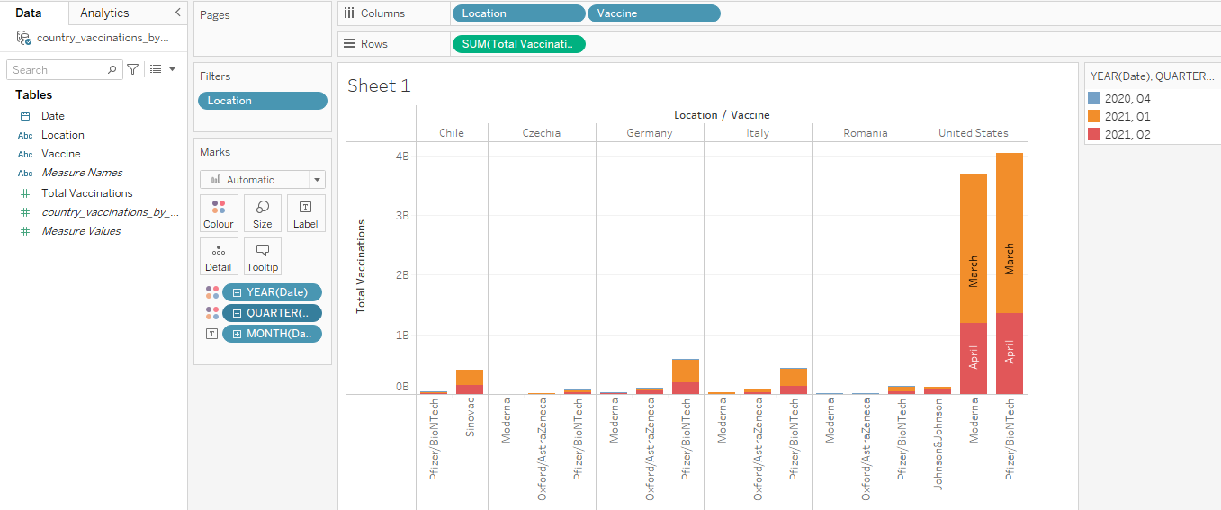

<https://www.kaggle.com/patrickb1912/ipl-complete-dataset-20082020>

Result shows the winners according to toss winner and toss decision

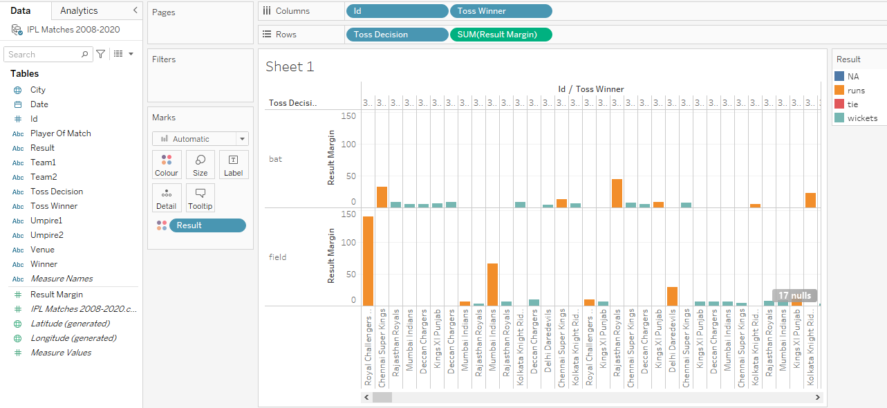

<https://www.kaggle.com/jr2ngb/superstore-data>

Result showing discount divided quarterly and the profit shown for every quarter.

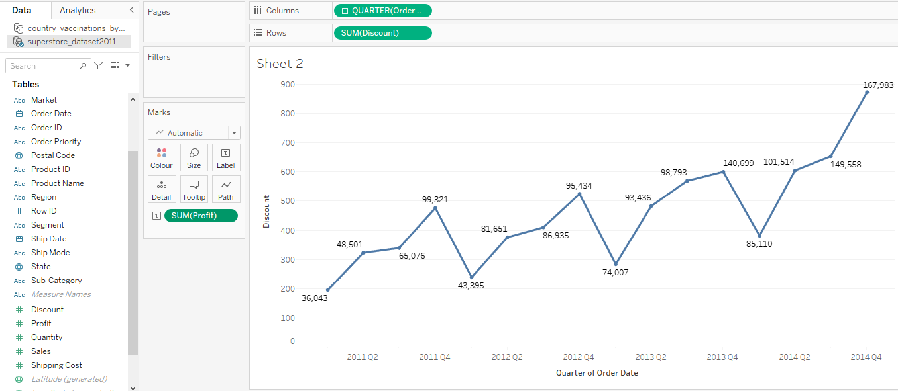

<https://www.kaggle.com/jr2ngb/superstore-data>

Result shows in pages of profit over the quarters

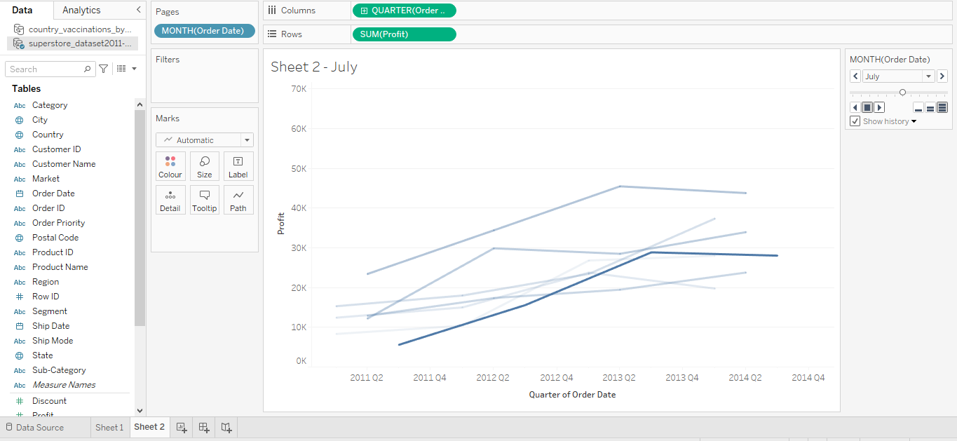

Dashboard1

